MANIPAL INSTITUTE OF TECHNOLOGY

MOBILE APPLICATION DEVELOPMENT

MINI PROJECT

TOPIC: **Inventory management Application (Ware-Hub)**

**UI Sketch**

By Team 2

Batch 4

Dharmesh Kashyap: 230970133

Saumya Raj: 230970120

Dhanraj j. Poojary: 230970145

Kavya Pandit: 230970124

Deekshith Devadiga: 230970123

# Table of Contents:

|  |  |  |
| --- | --- | --- |
| **No** | **UI Page Name** | **Page no** |
|  | Splash Screen |  |
|  | Registration |  |
|  | Login |  |
|  | Forget Password |  |
|  | Dashboard |  |
|  | View Low Quantity Items |  |
|  | Menu button: |  |
|  | Manage items |  |
|  | Edit items |  |
|  | Add items |  |
|  | Bill |  |
|  | Generate Bill |  |
|  | View Bill |  |
|  | Report |  |
|  | Report download window |  |
|  | Settings |  |
|  | Contact us |  |

**Splash Screen:**

**Splash Screen for WareHub**

The **splash screen** for the **WareHub** inventory management application serves as the initial visual interface when the app is launched. It displays the app’s logo and branding elements, providing a smooth transition while the app loads in the background.

**Splash Screen:**

**Registration page:**

Logo

* **User Input**: Users provide their email, username, and password.
* **Validation**: Ensure the email format is correct and the password meets security criteria.
* **Storage**: Securely store user credentials in the database with encryption.

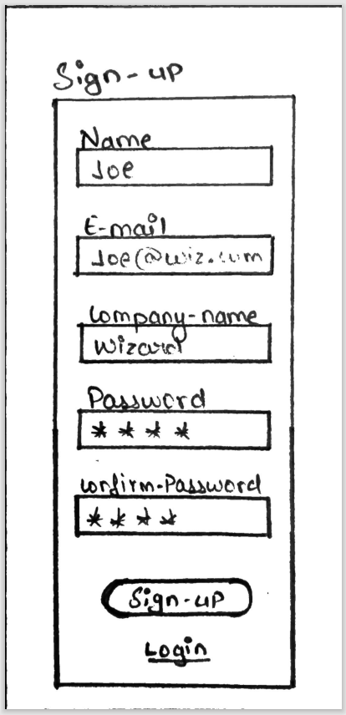**Registration page:**

**Login Page:**

* **User Input**: Users enter their registered email and password.
* **Authentication**: Verify credentials against the stored data.
* **Session Management**: Create a user session upon successful login to maintain user state.

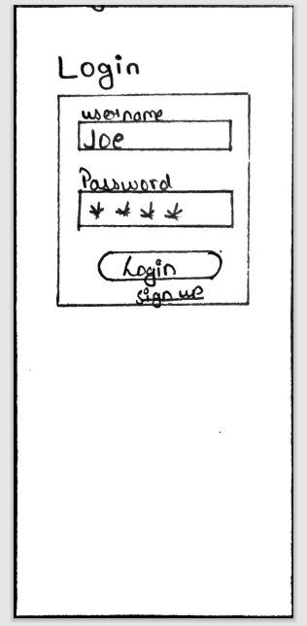**Login Page:**

**Dashboard:**

1. **Search Product:**
   * Functionality: Allows users to quickly search for specific products within the inventory.
2. **Total Items:**
   * Display: Shows the total number of items currently in the inventory.
   * Update: Automatically updates as items are added or removed.
3. **Total Value of Items:**
   * Calculation: Displays the total monetary value of all items in the inventory.
   * Update: Reflects real-time changes based on inventory adjustments.
4. **Today’s Bill Generated:**
   * Summary: Provides a summary of all bills generated for the current day.
   * Details: Includes total sales amount and number of transactions.
5. **Low Quantity Products:**
   * Alert: Lists products that are low in stock.
   * Threshold: Users can set a minimum quantity threshold to trigger alerts.
6. **Back Button:**
   * Functionality: Enables users to return to the previous screen.
7. **Small Option Menu:**
   * Access: Provides quick access to additional features and settings.
   * Options: Include settings, Contact info, logout, and other relevant options.
8. **Scroll bar:** 
   * Navigates content up and down

**Dashboard page:** 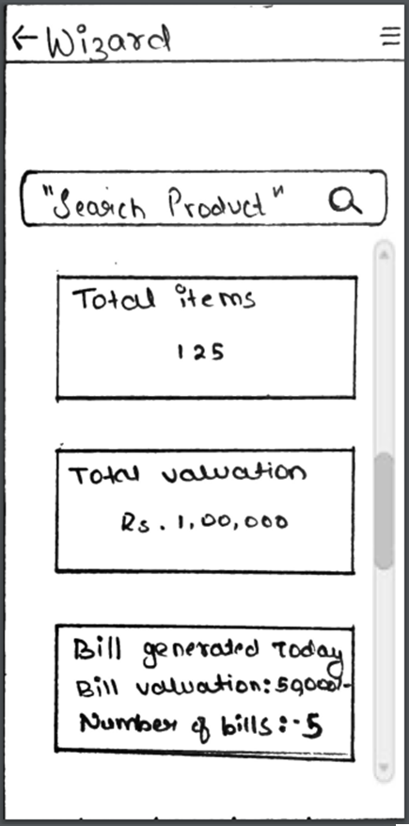



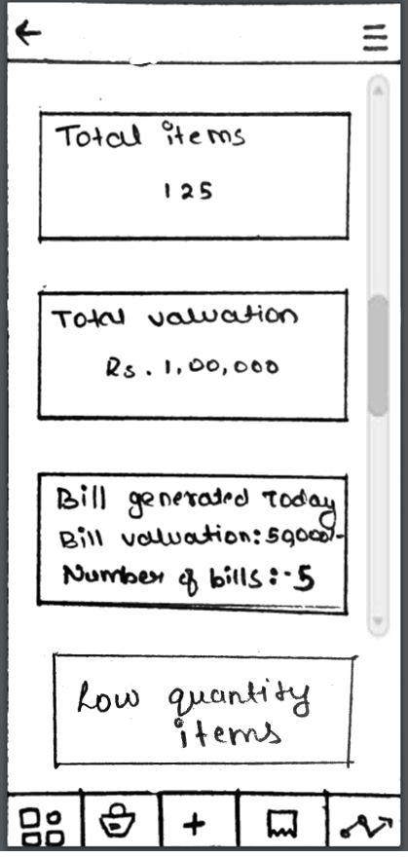**Scrolled View:**

**View Low Quantity Items**

* View the list of low Quantity of items

**Low Quantity item page:**

**Menu:**

* **Profile**: View and manage user profiles.
* **Settings**: Configure app preferences.
* **Contact Info**: Access contact details.
* 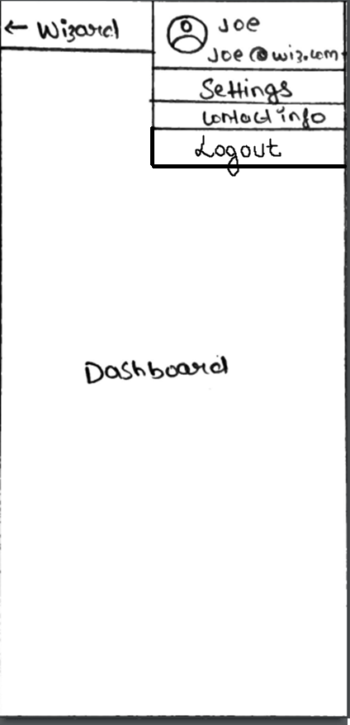**Logout**: Log out of the app.

**Menu page:**

**Manage items:**

The “Manage Items” screen allows users to view, add, edit, and delete inventory items. It serves as a central hub for managing the stock within the system.

* List details like name, quantity, price, and category.
* Implement search, filters, and CRUD operations.

**Edit items:**

* Allow users to modify existing item details such as price, quantity, and name.
* Scan Barcode feature to add items.

**Edit item page:**

**Edit items:**

* Allow users to modify existing item details such as price, quantity, and Name.
* Scan Barcode for auto editing the product.
* Provide a user-friendly interface for seamless editing.

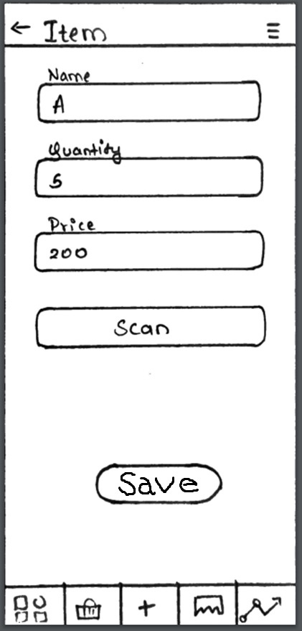**Edit items page:**

**Bill**

* Bill page have two buttons Generate Bill and View Bills redirecting to separate page respectively

**Generate Bill**

1. **Item Selection**:
   * Identify the items that need to be included in the bill
2. **Calculate Total**:
   * Sum up the prices of the selected items.
3. **Display Bill**:
   * Create a clear and organized bill format.
   * Include item names, quantities, individual prices, and the total amount.
4. **Print or Share**:
   * Provide an option to print the bill

**View Bill**

* Retrieve bill data (such as itemized details and total amount) from your database.
* Allow users to select a bill they want to delete.

**Report**

**CSV Export**:

* Format the retrieved data into a CSV (Comma-Separated Values) format.

**Settings:**

### Reset App Data

* **Purpose**: Allows users to restore an app to its default state.

### Dark Mode

* **Purpose**: Adjusts the system-wide color scheme to a dark background.

**Contact Info**

* Developer contact page

